Howden Equestrian Centre

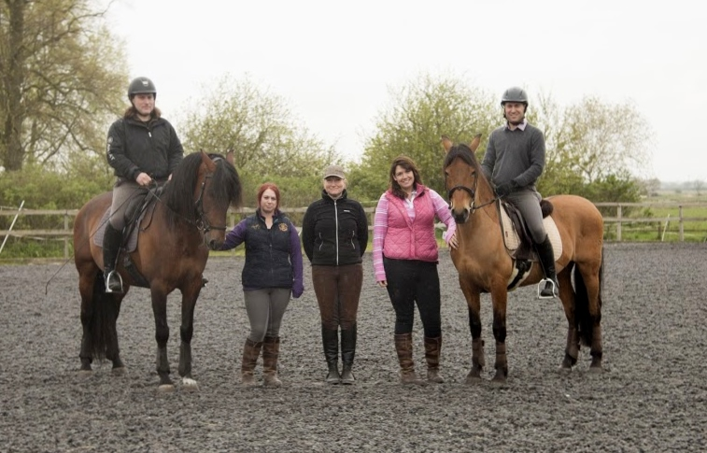

**Terms and conditions 2024.**





**Terms and conditions**

1. **ALL Clients:** 
   1. Must have completed a Rider Registration Form before riding a horse. This will be countersigned after the lesson by an instructor.
   2. Must resubmit their Rider Registration Form if their details change. (the responsibility falls to the Parent/Guardian if the child is under 18).
   3. We reserve the right to refuse you to ride a particular horse/pony if we feel that the safety of the rider or horse is in question.
   4. You reserve the right to change to another horse/ pony, providing one is available, and it is practical and safe to do so.
   5. You also have the right to request another Instructor subject to availability.
   6. We reserve the right to refuse custom from any customer.
2. **Punctuality and Arrival Times:** 
   1. Please arrive 5 minutes before the start of the lesson to allow time for hat fitting.
   2. If you are late, we unfortunately cannot make that time up as other clients will be waiting for their lessons to start on time. You will not be refunded for missed lessons.
   3. If we are running late for whatever reason we will make up your lesson time
3. **New Clients:**
   1. Are required to attend an assessment lesson before being allowed join an existing group. This allows us to ascertain your riding level.
   2. All Clients Rules Apply.
4. **Payments:**
   1. If you fail to turn up, you will be required to pay in full.
   2. All lessons should be paid for either in advance or on the day of the lesson. Lessons paid for more than 24 hours after the lesson will be subject to a £5 per week (per rider) admin fee.
   3. Payment is to be made via BACS in advance of your lesson, or cash on the day.
5. **Cancellations:**
   1. 48 hours’ notice MUST be given for any cancellations.
   2. If less than 48 hours’ notice is given, the lesson will be charged for at the full rate. This includes all cancellations, regardless of reason, and does include illness.
   3. All cancellations must be sent to the office directly, either via messenger (text, email or Facebook), or in person directly in the office, and it is noted in the diary.
   4. No cancellations made through the instructor will be accepted. All cancellations must go through the office.
   5. There is no exception to our cancellation fee. All lessons are chargeable with less than 48 hours notice.
   6. We reserve the right to refuse further bookings if our payment and cancellation terms and conditions are not adhered to.
6. **Instructors:**
   1. Instructors reserve the right to refuse to teach a client for any reason.
7. **Bad Weather or Conditions:**
   1. Activities might be cancelled in extreme weather.
   2. You should call us on 07562393494 before you leave for the Centre if you are in doubt. If we have not contacted you, please do not assume the lesson is cancelled, often it is not as bad here as it might be elsewhere.
   3. **You will always be contacted should your lesson be cancelled completely.**
   4. We reserve the right to cancel riding because of bad weather at any time.
   5. Lessons will run unless you are contacted.
   6. We reserve the right to substitute riding lessons for horse care (stable management lessons) at any time.
8. **Safety Equipment and Riding Wear:**
   1. P.P.E (Personal Protective Equipment): Every time you handle a horse you are required to wear the appropriate Personal Protective Equipment.
   2. **Riding Helmets:**
      1. Hats (all types): Should be up to current BHS riding standards
      2. Must be worn and fastened at all times while riding a horse.
      3. Must be worn and fastened at all times while handling or a horse.
      4. We strongly advise all customers to purchase their own helmet as soon as possible.
         1. We recommend **against** purchasing second hand riding helmets in case they have been damaged.
         2. We reserve the right to refuse you lessons if hat is not up to standard
      5. We reserve the right to charge customers for helmet hire after 1 lessons have passed.
         1. Cost per Session is £5.
   3. **Body Protectors:**
   4. We do not provide body protectors, nor can we fit one, we are not qualified fitters
   5. Use of body Protectors is a choice which is down to parent’s discretion.
   6. **Riding Footwear:**
      1. Clients must wear appropriate footwear while riding.
      2. Allowed Footwear:
         1. Jodphur Boots
         2. Riding Boots
         3. Wellies with a small heel
         4. Most boots with a small heel
      3. Disallowed Footwear:
         1. Trainers
         2. High Heels
         3. Sandals
         4. Flipflops
         5. We reserve the right to refuse footwear we deem unsafe.
      4. We recommend toe protection whenever handling a horse.
   7. **Jewelry:** 
      1. You should not wear Jewelry of any kind, anything you wear, you do so at your own risk.
      2. It's the parents responsibility to check their child isn't wearing Jewelry.
9. **Extra Visitors and/or Friends of the Family:**
   1. Children must be supervised at all times by a legally responsible person.
   2. Parents are advised not to leave your children unattended at any time during their stay
   3. If spectating, please remain as quiet as possible, and in full view of the horses/ponies & Instructor at all times.
   4. Whilst spectating, the Instructor reserves the right to ask you to leave the arena area for any reason.
   5. Young Children: Must be supervised at all times by a responsible person and remain seated and quiet whilst lessons are in progress and not to run around. No climbing or sitting on fences is allowed.
   6. No running / shouting / jumping etc on the yard at any point. Please do not run past the main arena.
   7. No climbing on fences or standing on arena gates.
10. **Movement of Horses & ponies and Farm Equipment** around the yard and surrounding areas is unavoidable and we ask you to give way to them at all times.
11. **Out of Bounds:**
    1. There are No Entry Type signs and safety notices posted around the facility, you must acknowledge and obey them, ignoring them is at your own risk.
    2. The stable yard is no entry except for when collecting a horse. Please do not access the yard to view or pet the horses. The yard is closed for their welfare, and your safety. Please do not allow children to ignore yard signage.
12. **Warning Signs:** We have many different warning signs on the yard, they are there for a reason, you must obey them. We reserve the right to ask you to leave at any time if we think you are a danger to yourself or others.
13. **Filming and photography:** We ask that you do not film or take photos on the premises without permission from a staff member. In group lessons you must not take photos that have other riders / spectators in the photos. All photos must be taken with instructors permission with an empty background for safeguarding reasons.
14. **Smoking Policy:** We have a Strict No Smoking Policy anywhere on the premises, if you are caught you will be asked to leave. This includes vaping.
15. **Pets:** We don't allow any clients to bring their own pets onto the grounds/premises.
    1. Guide Dogs are allowed by prior arrangement.
16. **Horses/Ponies:** All animals are unpredictable, Do Not Feed the Horses & Ponies at any time. Don't enter any field, box or make contact with a Horse or Pony at any time, without prior authorization from a member of staff.
17. **Cars, Bicycles:** We can't be held responsible for any damage to your transportation while on the premises/grounds. All vehicles are parked at your own risk.
18. **Personal Property:** We can't be held responsible for Damage, Theft or Loss of your personal property while it's on the premises.
19. **OTHER:**
    1. Parking is not permitted outside the gateway / blocking neighboring gateways.
    2. The drive is not a footpath and walkers are advised to take extreme care due to the uneven surface.
    3. Maximum Speed on the premises / private driveway is 10 mph.
    4. We reserve the right to refuse the custom of any customer.
    5. All our staff have the right to not be abused, and will not accept any verbal or physical abuse from customers or visitors.
    6. Our staff have the right to ask you to leave the premises if they feel it is necessary.
20. **RIDING IS A RISK SPORT** - Your choice to ride is voluntary. We take all reasonable care to provide suitable and safe horses and ponies for all our clients. All animals can be Unpredictable. We strongly advise you to take out full personal accident cover.
21. **PLEASE NOTE:** Howden Equestrian Centre, Owners & Staff cannot be held responsible for any accident, injury or loss to any persons or their property whilst on these premises or whilst out hacking.
22. **Agreement of Terms:** If you do not agree with any of Terms and Conditions, then you do not have permission to enter the premises and any bookings are null and void. Our no Cancellation Policy applies in this situation also. Our Terms and Conditions are available online to view and on request at any time. The booking policies are explained in our welcome pack on booking your first lesson. It is your responsibility to read through this before your first lesson.
    1. As such you have every opportunity to read them before booking any activity and a refund will not be available on failure to accept them.